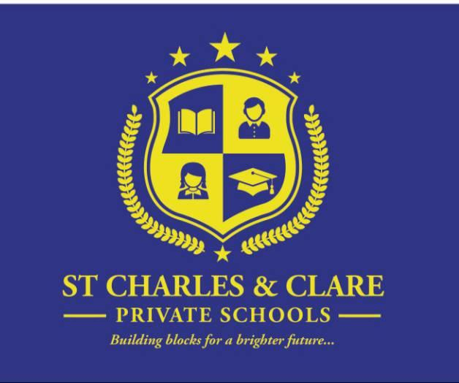
ST CHARLES AND CLARE PRIVATE SCHOOLS FEES STRUCTURE

FEES PER TERM
Baby Class (1-2 years) | K90,000
Lower Class (2-3 years) | K90,000
Middle Class (3-4 years) | K90,000
Upper Class (4-5 years) | K90,000
UNIFORM (MANDATORY)
Boys – Shirt, Trousers, Jersey and Tie | K20,000
Girls – Blouse, Dress, Jersey and Tie | K20,000
SPORTS UNIFORM (OPTIONAL)
This applies to those who would want the school to arrange the sportswear for child
T-shirt and shorts | K 10,000
DAY CARE (07: 30 AM - 5:00 PM (OPTIONAL)
This applies to those who would want the school to be preparing the food for their Child
Food | K20,000

ACCOUNT DETAILS
BANK ACCOUNT NAME | ST CHARLES AND CLARE PRIVATE SCHOOLS
BANK NAME | ACCOUNT NUMBER | ACCOUNT TYPE | BRANCH NAME
NATIONAL BANK | 1010479289 | SAVINGS | CITY CENTRE

CONTACT DETAILS
NAME | PHONE NUMBERS | EMAILS
School | 0884996885 | director@stcharlesandclareschools.com
Operations manager | 0994557334 | admin@stcharlesandclareschools.com
Supervisor | 0991930419 | info@stcharlesandclareschools.com

NOTE: registration fee – K5000 and our Office will be open starting from 3 January for registration. Be the first to register and get a free school uniform

